Assembly and Operations Instructions for Companion Board

Parts List

|  |  |  |
| --- | --- | --- |
| Part | Vendor | Part Number |
|  |  |  |
| 6-pin Fixed Terminal Block 6P 3.81mm 90DEG | Phoenix | 651-1727036 |
| 4-pin Fixed Terminal Block 4P 3.81mm 90DEG | Phoenix | 651-1727052 |
| LED1, GREEN, SMD, 570nm, 0805 package | Osram | 720-LGR971-KN-1 |
| R1 560 Ohms, 0805 package | Panasonic | 667-ERA-6APB561V |
| R2 560 Ohms, 0805 package | Panasonic | 667-ERA-6APB561V |
| R3 220 Ohms, 0805 package | Vishay | 71-TNPW0805220RBEEA |
| SW1 DIP-3 | Wurth | 710-418117270903 |
| U$2 PVN012PVF | Infineon | 942-PVN012PBF |
| U$3 PVN012PVF | Infineon | 942-PVN012PBF |
| U$4 GY-521 (MPU6050) | MakerFire | NA |
| U$5 ARDUINO PRO MINI | SparkFun | NA |
| PC Board | OSHPark | NA |

Assembly

1. Tape the PC board to work surface face up to mount all SMD components. Since the three resistors are located underneath the Arduino Pro Mini, they must be placed first.
2. Solder the three surface mount resistors, R1, R2, and R3 at positions marked.
3. Solder the LED in place taking care that the LED polarity is correct. The cathode (negative) side is marked on the LED, and the positive side is marked on the PCB.

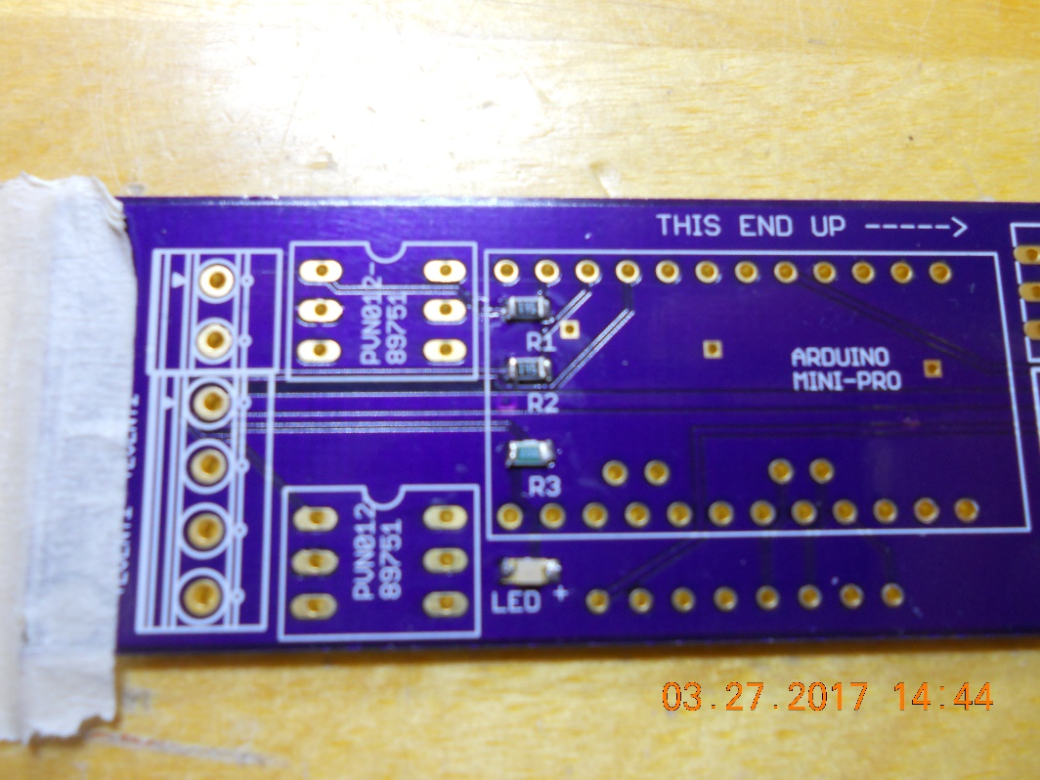

1. Check the circuit connections for the four SMD components using a DVM to ensure there are no shorts or open circuits. This is important because once the Arduino Pro Mini is in place, you cannot rework the resistor solder joints.
2. Solder the 6-pin header to the Arduino Pro Mini so the long pins extend above the board. This header will serve as the serial interface to the programming computer.
3. Solder two 12-pin headers to the Arduino Pro Mini so that the long pins extend below the board.
4. Solder the 2-pin header into the companion board PCB into positions D4/D5 such that the long pins extend below the board, and the plastic header is on top of the board. Trim the long pins close to the board on bottom.

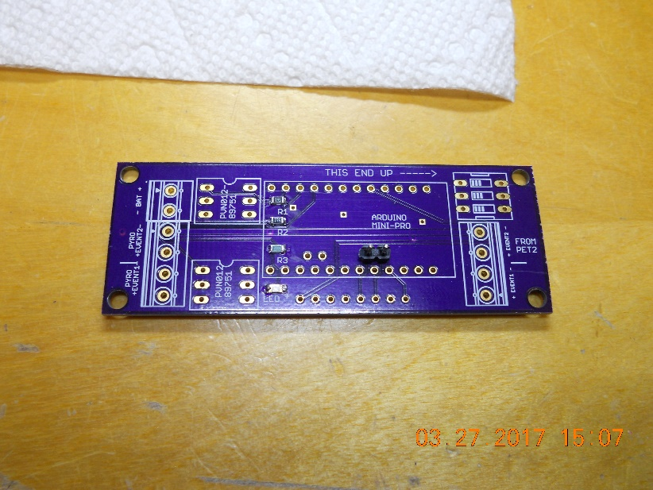

1. Solder the Arduino Pro Mini to the companion board, ensuring that all 26 connections are made. Trim leads close to board on bottom.

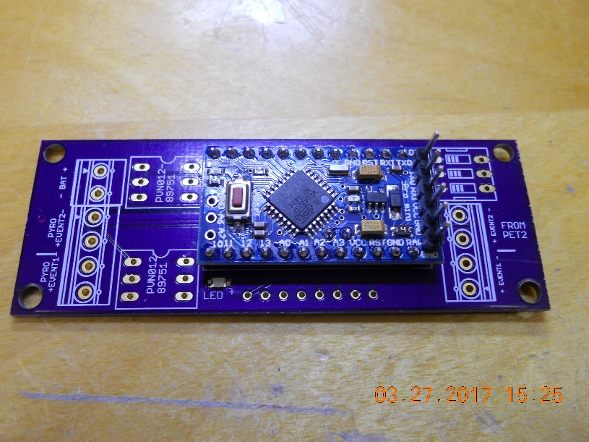

1. Solder 8-pin header to the GY-521 board so that the long pins extend to the bottom of the board.
2. Solder the GY-521 board to the underside of the companion board as depicted in the silkscreen. Ensure that the two boards are parallel to each other.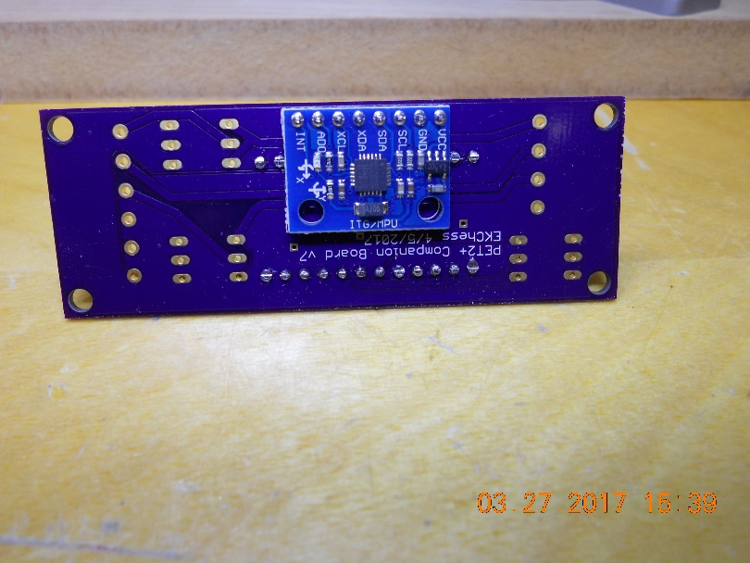
3. Solder the two SSRs to the companion board as marked. Ensure the proper orientation of the ICs as marked on the silkscreen.
4. Solder the 3-position DIP switch to the companion board. Ensure correct orientation of the DIP switch as marked on the silkscreen.
5. Solder the 4- and 6-pin screw terminal blocks to the companion board. Ensure the correct orientation of the terminal blocks (open side faces to edge of board).
6. Trim any soldered leads close to board. This completes the assembly.

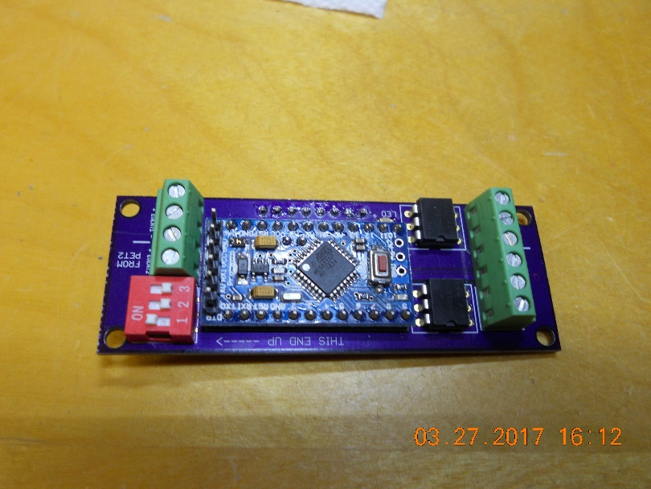

Programming and Calibration of GY-521

1. Calibrate the GY-521 board by uploading the calibration sketch to the companion board. The board should be supported such that the bottom of the board faces up (exposing the GY-521 breakout board) and the board is horizontal to the work surface. This puts the board’s Z-axis perpendicular to the plane of the board, and in line with earth’s gravity.
2. Open the serial monitor and observe the readout. When the calibration is complete, values for the accelerometer and gyroscope offsets will be displayed. Copy these values down, keeping track of the various axes. You will input these offset values in the companion board sketch.
3. Open the companion board sketch in the IDE. Update the offset values in the setup program segment and save the sketch. Recompile to check for errors.
4. Upload the updated companion board sketch to the companion board.

Operation of the Companion Board

The PET2+ Companion Board is an attitude-based air-start ignition control device used in conjunction with an ignition timer to ensure safety of the event. The Companion Board utilizes a three-axis accelerometer and a 3-axis gyroscope to monitor the attitude of the rocket in flight (specifically the rocket’s tilt from vertical). The critical angle from vertical can be set with a 3-position DIP switch (from 5-40 degrees in increments of 5 degrees). Once the board has detected liftoff (by monitoring the Z-axis acceleration), any deviation from vertical larger than the critical angle will trigger the closure of solid-state relays that will prevent any electrical power from the timer or flight computer reaching the ignitors. The Companion Board can monitor two ignition pathways. It will work with flight computers or timers that have a constant positive hot terminal and a second terminal that is switched to ground when the timer or flight computer fires. The Companion Board is connected to the timer or flight computer on one end, and to the ignitor leads on the other end.

Orientation: The Companion Board should be installed in the rocket such that the arrow on the top of the board (This End Up) faces the rocket’s nosecone.

Connections: The six-pin terminal block on the bottom of the board contains the two battery connections on the left and two sets of ignitor connections on the right. A battery between 5 and 12 V DC can be used. Hook the battery leads into the properly marked terminals on the board to avoid risk of damaging the board. Hook the ignitors to the terminal blocks on the right. The board is marked with Event 1 and Event 2 (Pyro) designations, and each ignitor pair of leads should be attached to the pair of terminals with the same event designation. The four-pin terminal block at the top of the board is where to connect wires from the timer or flight computer corresponding to the Event 1 and Event 2 (From PET2) designation.

Setting the Critical Angle: The critical angle is set from 5-40 degrees (NAR guidelines recommend not more than 20 degrees) using the 3-pim DIP switch as denoted in the table below. This selection must be made before powering the board for the flight.

|  |  |  |  |
| --- | --- | --- | --- |
| Critical Angle in Degrees from Vertical | Switch 1 | Switch 2 | Switch 3 |
| 5 | OFF | OFF | OFF |
| 10 | OFF | OFF | ON |
| 15 | OFF | ON | OFF |
| 20 | OFF | ON | ON |
| 25 | ON | OFF | OFF |
| 30 | ON | OFF | ON |
| 35 | ON | ON | OFF |
| 40 | ON | ON | ON |

Power Up and Operation: Upon applying power to the board (there is no power switch on the Companion Board), the board will orient itself and read the DIP switch positions. The green LED will blink out the number of degrees using in short flashes with a longer flash between digits (it will blink 10 times for the numeral zero). Once the green LED stays solidly lit, the Companion Board is ready to be launched. The solid-state relays are switched on during the Companion Board power-up sequence, allowing an electrical connection from the timer or flight computer through the ignitors, allowing continuity checks to be completed. The timer or flight computer will not sense the presence of the Companion Board during the continuity check: the circuits will act like the ignitors are connected directly to the timer or flight computer. The Companion Board is insensitive to orientation with respect to solid-state relay control until it detects launch. Once launch is detected, the Companion Board will monitor the attitude of the rocket, and once the attitude angle diverges from vertical by the critical angle or greater, the solid-state relays will be deactivated and locked in that OFF state until the board is rebooted. This prevents an air-start if a rocket is looping and happens to have an attitude that is within the critical angle from vertical when the timer or flight computer activates the ignition current (all timers and many flight computers are unaware of the rocket’s attitude). When the solid-state relays are turned off, the green LED is also turned off. You should note that the green LED is off upon recovering your rocket, as the Companion Board will have shut off the relays when it arced over at apogee. This also “safes” any ignitors that may not have fired during the flight. However, intermittent loss of power to the Companion Board will reboot it, so caution should be taken to power-off all electronics before handling the rocket during recovery.